Creator Studio

Stockholm Summit 2024

Creator Studio – Apps for anyone

Unlock development across the business

1

Table of Contents

Creator Studio – Apps for anyone 1

Unlock development across the business 1

Access Creator Studio 5

Choose template 7

Add your request application to a Service Catalog 8

Preview in various experiences 9

Section Complete 9

Creator Studio – Edit view 10

Edit your request form 11

Edit the form 12

Section Complete 12

Create a Playbook for Automation 13

Section Complete 15

Introduction

Overview

ServiceNow Creator Studio offers a curated experience to build simple applications within guard rails on ServiceNow.

Goal

Get a glimps of how Creator Studio works and be able to create a simple application with a playbook to guide a user working on a task.

Background

You support Jake, a marketing director In your organization. Jakes team is exceeding their goals, and Jake wants to reward them.

The company has a rewards process where a manager can request one of a number of different approved rewards to their team. The process however, is manual and time consuming today. Jake has asked you to recreate the process on ServiceNow using Creator Studio.

Lab

ServiceNow Instance Access

Log in to your instance using the details provided to you.

The user name is “admin” and you will be playing the role as a platform admin in this exercise. The rest of the login details are provided at your seat.

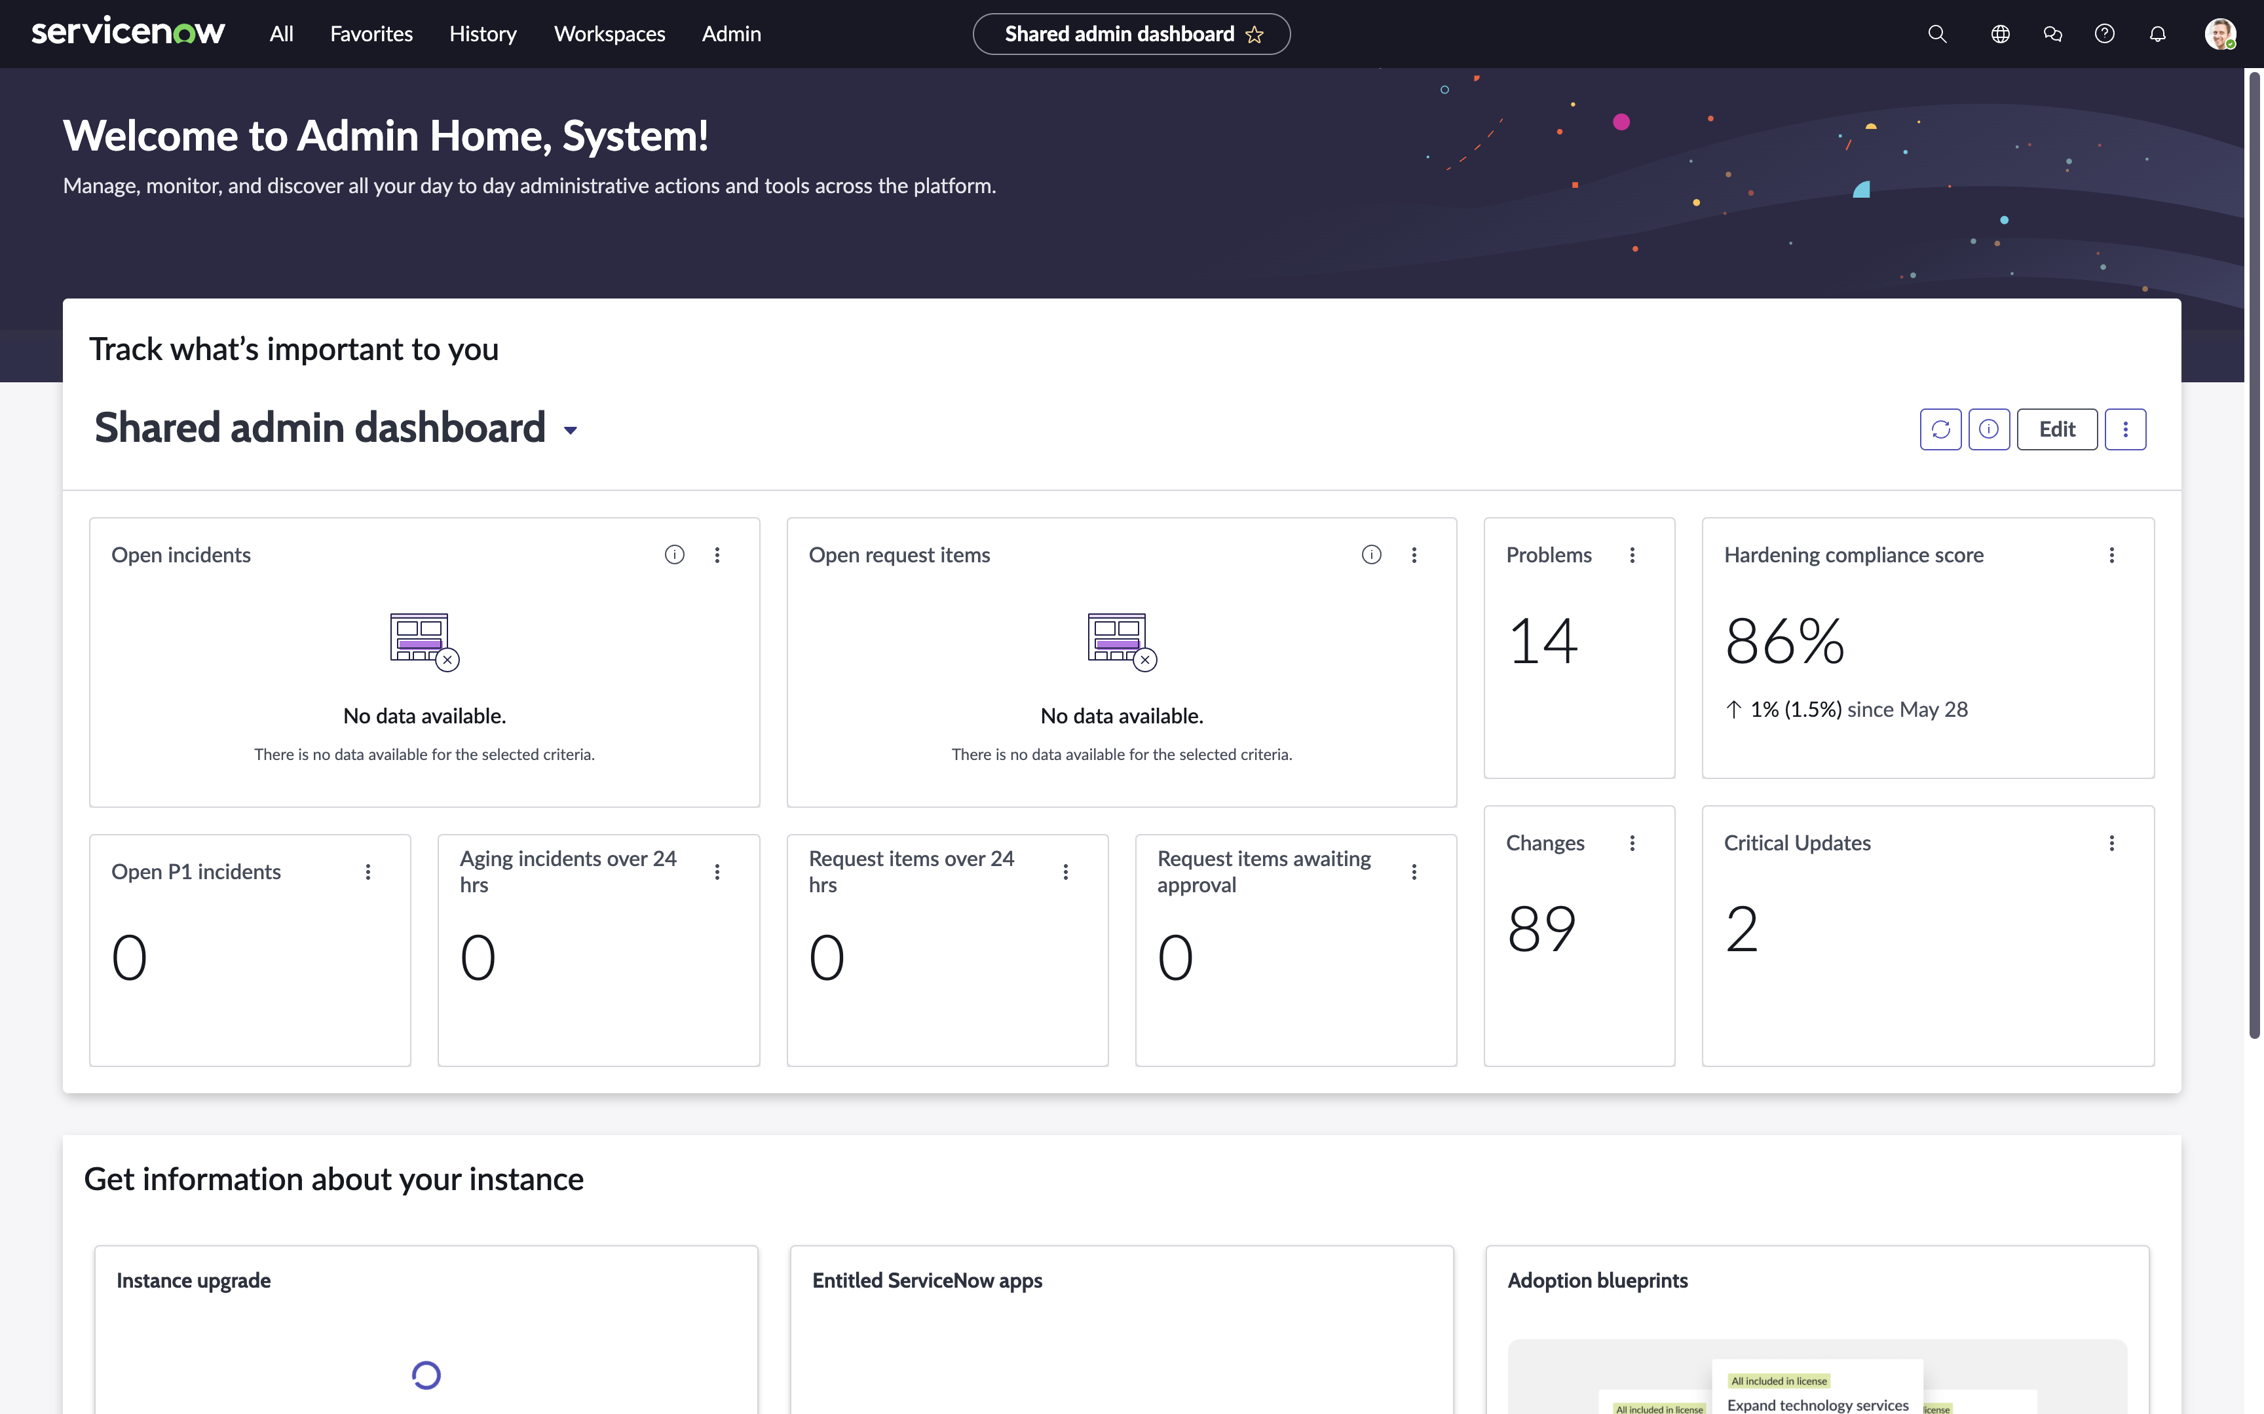

Since the instance you are using is brand new, there will be various “Welcome” and “Get Started” popups throughout – these can be be closed or you can click through them.

Access Creator Studio

1. In the top left click the menu **All**
2. Type **Creator Studio**
3. Click **Creator Studio** below under App Engine

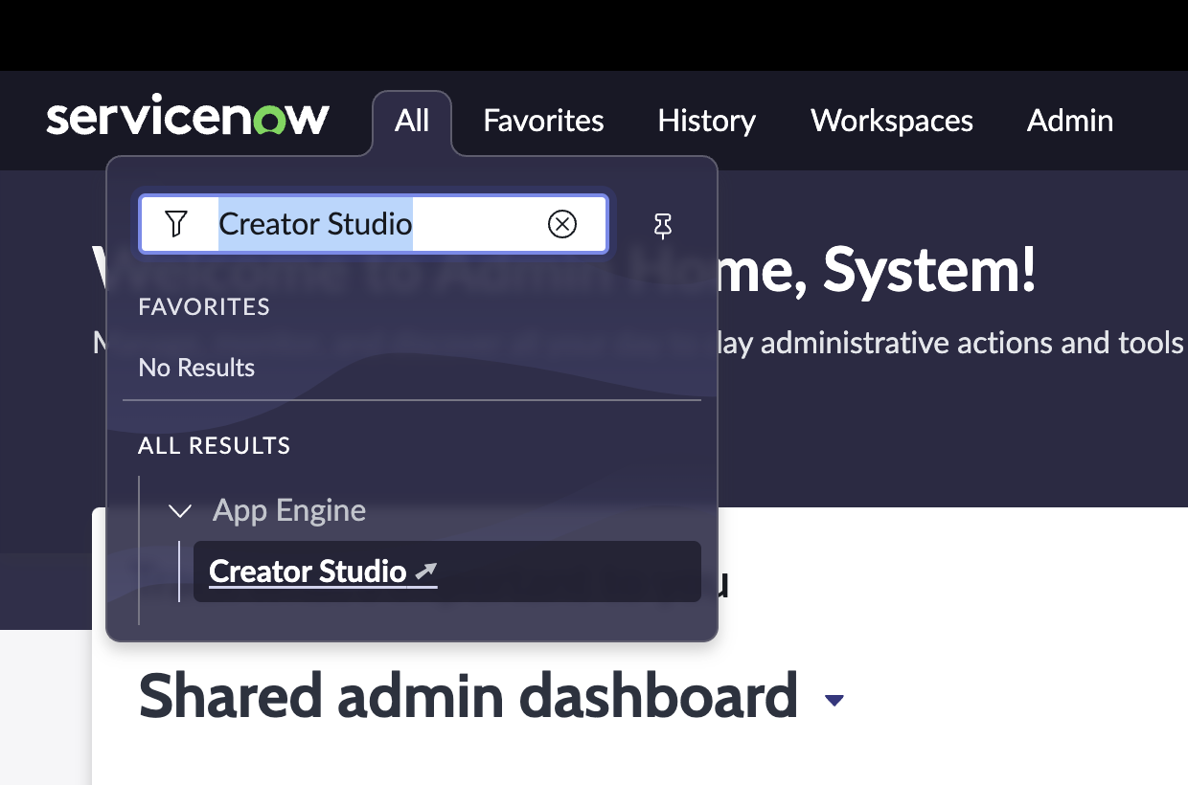

Creator Studio will open in a new tab in your browser. Keep them both open.

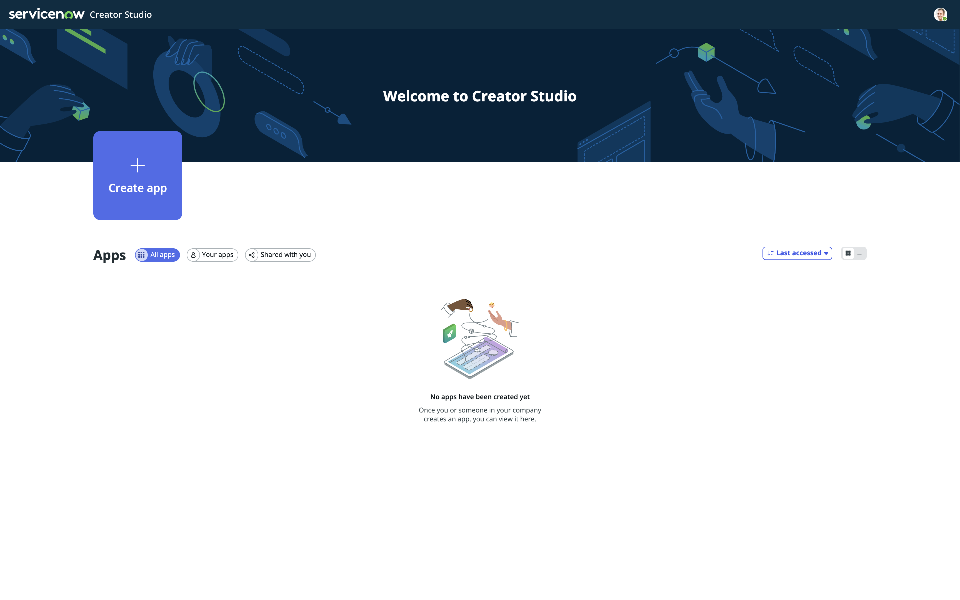

Create your first application in Creator Studio

Let’s get started building an application!

1. Click **Create app** and enter the following:
2. Name: **Gift card request**
3. Description: **Request for both internal and external gift cards for employee recognition**
4. Click on **Create app**

Note: This will create a “scope” in ServiceNow that will house all the artifacts of your application. This also allows for easy deployment from Development to Test and then to Production when that time comes.

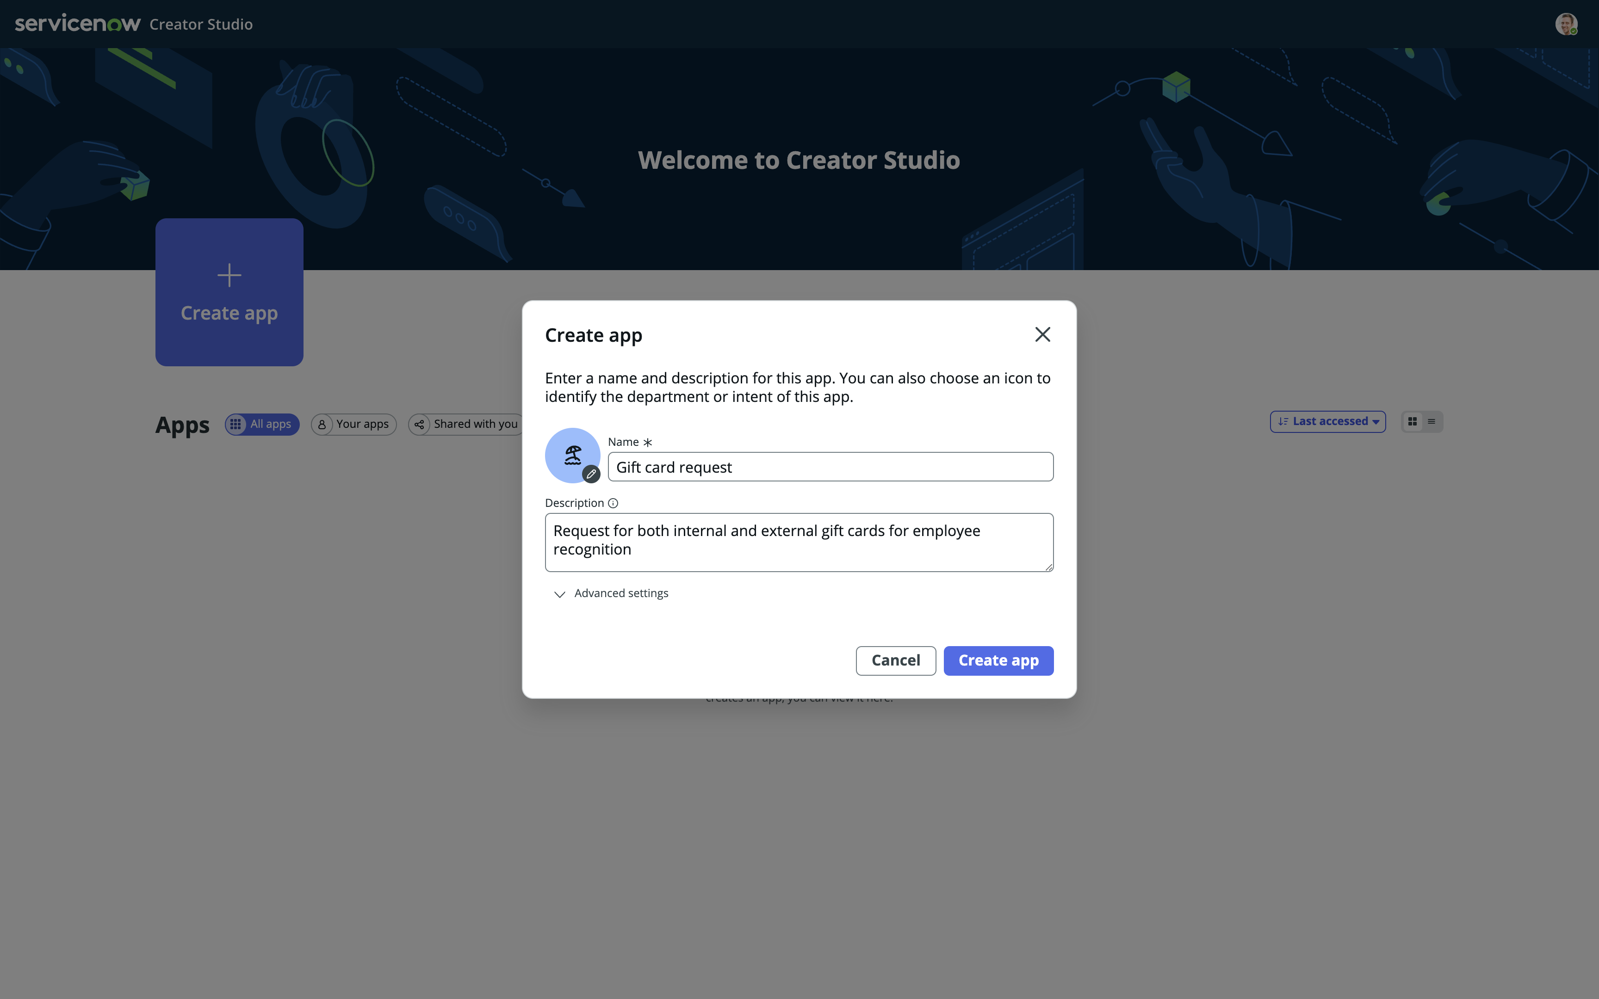

You can enter what ever you want in the Name and Description boxes, it will not have any functional impact on the Lab.

Choose template

Creator Studio currently comes with one teamplate. “Creator Studio Default Template”.

On the left hand you see the available templates, your instance includes two.

On the right hand side, you will se a preview of the choosen template.

1. Click and select **Creator Studio Default Template**
2. Click **Apply this template**

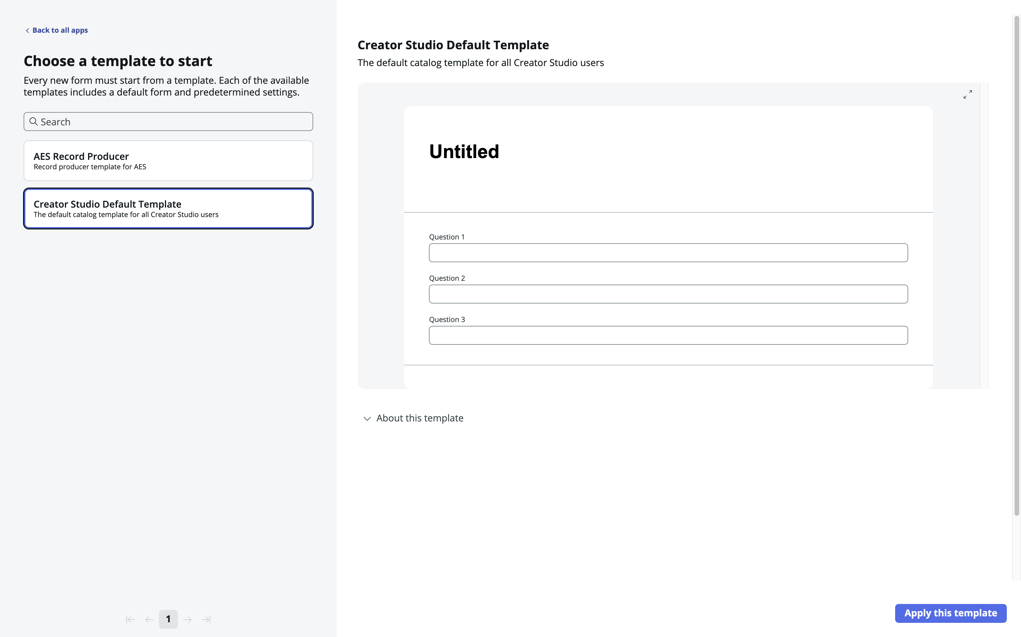

Add your request application to a Service Catalog

You can add the application, or rather, the Catalog Items for your request process, to one or more Service Catalogs and Categories.

For now, we will use “Service Catalog” and the category “Departmental services”

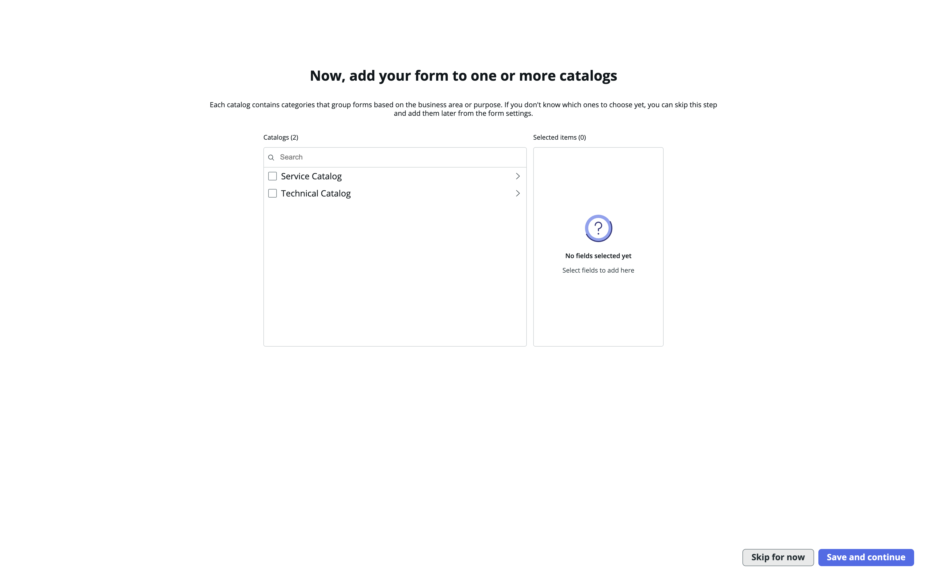

1. Click the arrow next to **Service Catalog** to reveal its categories
2. Check **Departmental Services**
3. Click **Save and continue**

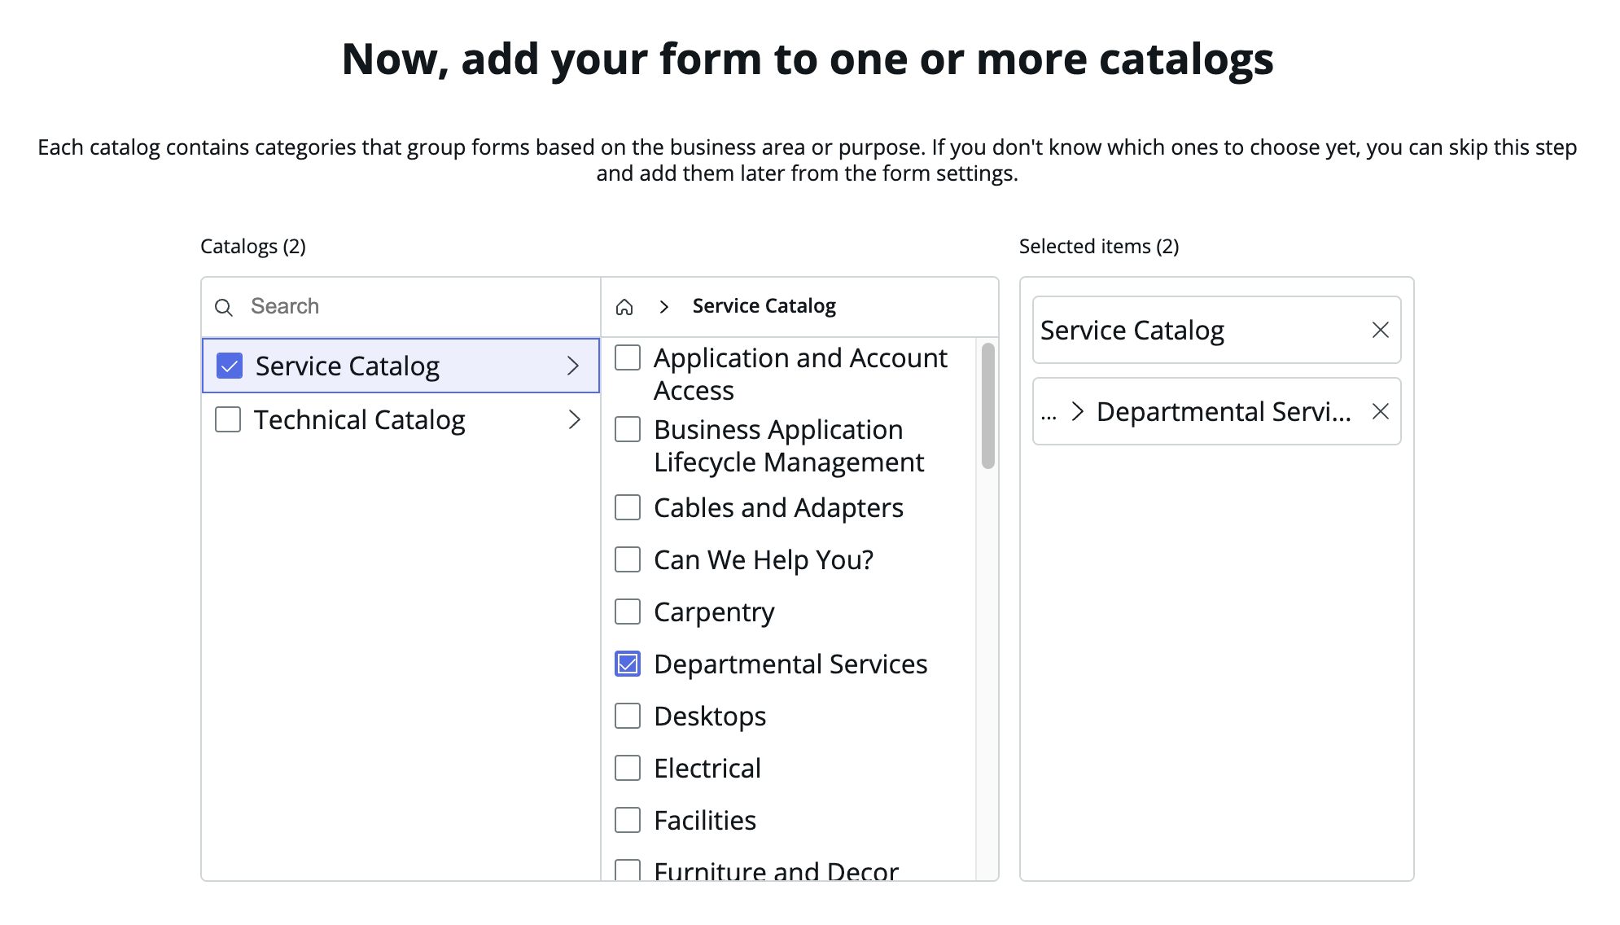

Preview in various experiences

ServiceNow provides various ways to consume its experiences. In this view, you will be able to get a preview of how your request will look in different user interfaces.

You will be able to return to this preview at any time to see your changes.

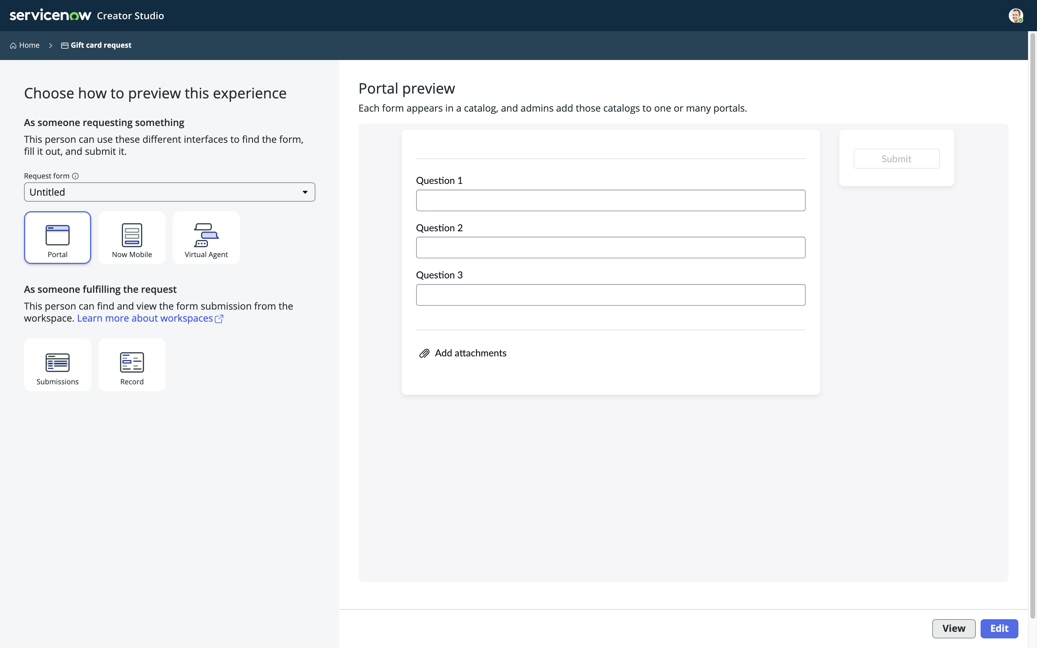

Feel free to explorer these views – you can return here at a later point.

1. Click **Edit** to continue

Section Complete

Congratulations, you have now created an application in ServiceNow.

Your next step will be to design the Request Form the user will use to Submit their request in your process.

Design your request form

In this section you will design the request form.

Creator Studio – Edit view

This is the edit view of Creator Studio.

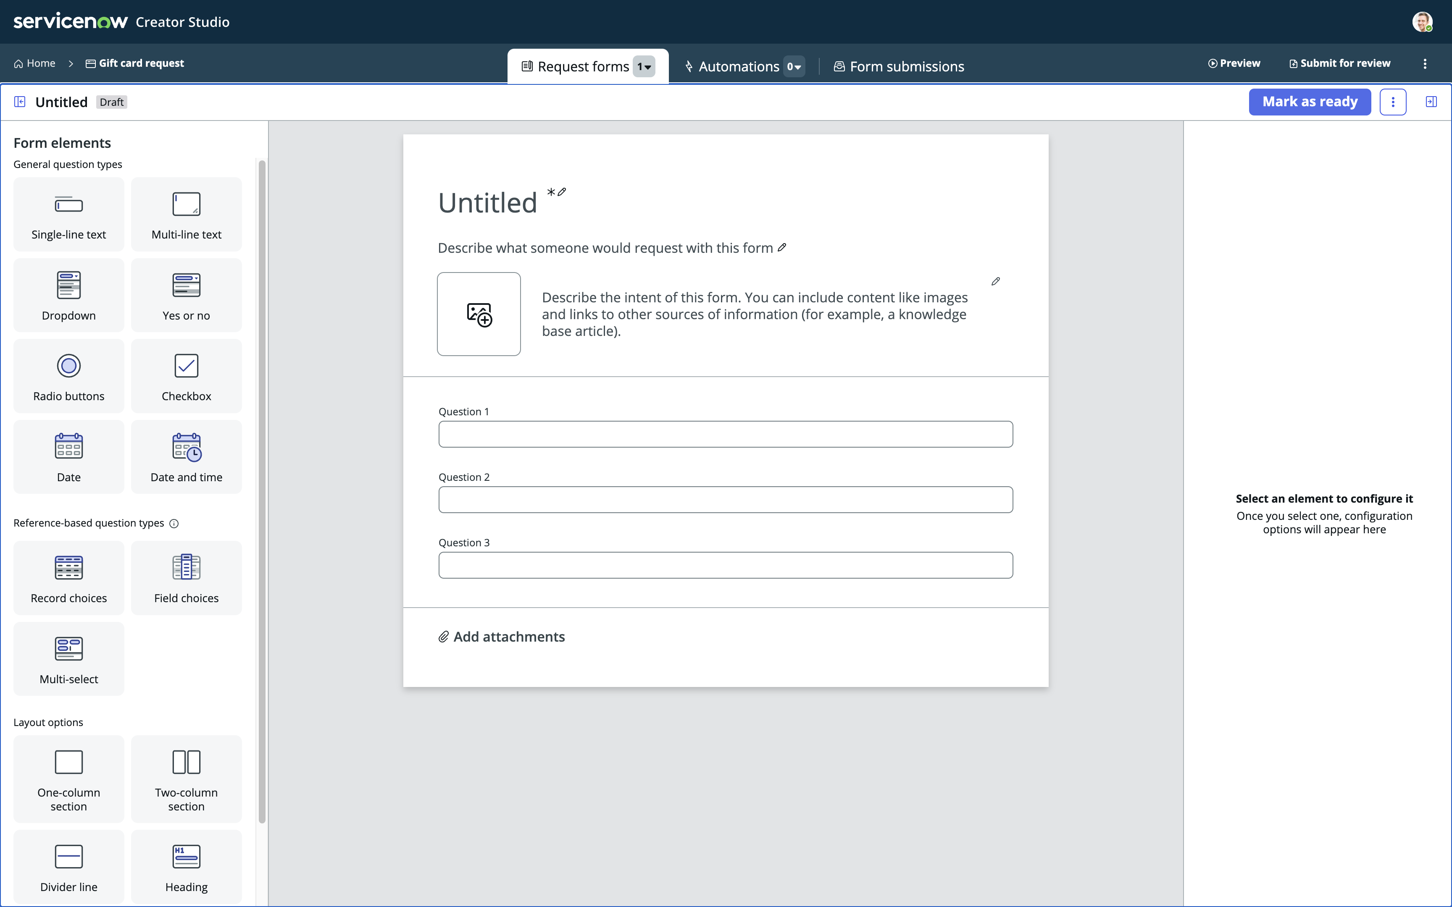

**Form Elements**

**Forms, Automations and Submissions**

**Element Configuration**

**Editing Area**

* **Forms, Automations and Submissions**  
  You can configure three major areas in Creator Studio
  + **Forms** – These will be your catalog items, your record producers. This is what your end user will use to start the process, to submit the request.
  + **Automations** – This is where you can create a Playbook to guide the process user, the fulfiller, on how to fulfill the request of the user.
  + **Form submissions** – This is where you can edit and configure the view the process user will have when they work on a request in the “Request App Workspace”.

On the screen you also see:

* **Form Elements**
  + These are the elements you can drag & drop on to the Editing Area. Each element has different capabilities.
* **Editing Area**
  + You drag and drop Form Elements on to this area to configure Elements you use to capture information from the user.
  + You also name the form (“Untitled” below), give it a description and potentially an image.
* **Element Configuration**
  + Each element has different configuration options, this is where you give the elements their Label, Instructions, Type etc.

Edit your request form

Let’s start by giving the form a Name and a Description. This information will be used to match what the user searches for in the Service Portal.

1. Click on **Untitled** and change it to **Gift card request**
2. Click on the line below and change it to **Request gift cards for employee recognition**.
3. Now click on the description right of the image place holder, notice you get a rirch text editor here. Change the content to:  
   **Looking for a great way to recognize your colleagues? Use this form to request a gift card to our internal company store or to a third party store of your choice! Internal gift cards under $50 will be automatically approved, all others will go through finance approval.**
4. **Optional:** You can click the image place holder and upload an image if you have one.

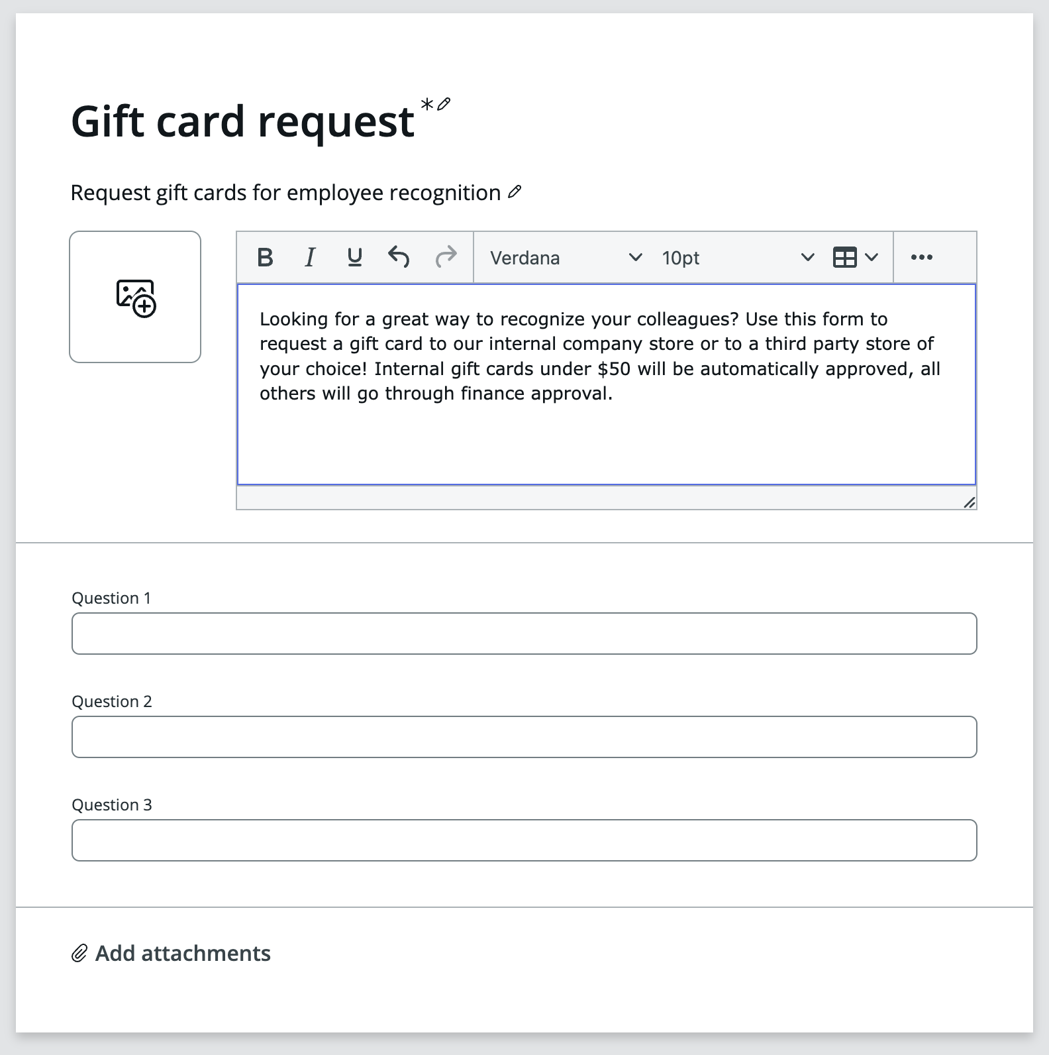

Our next step will be to define the options for the user, and replace the placeholder questions on the bottom half.

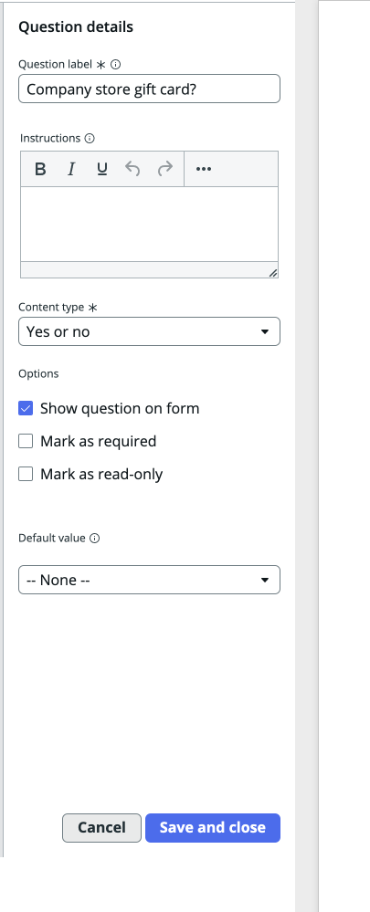Edit the form

1. Click to edit **Question 1** and on the right hand side change the following details  
   Question label: **Company store gift card?**Content type: **Yes or no**  
   Click **Save and close**
2. Click to edit **Question 2** and just like above, change the following details  
   Question label: **Amount**Click **Save and close**
3. 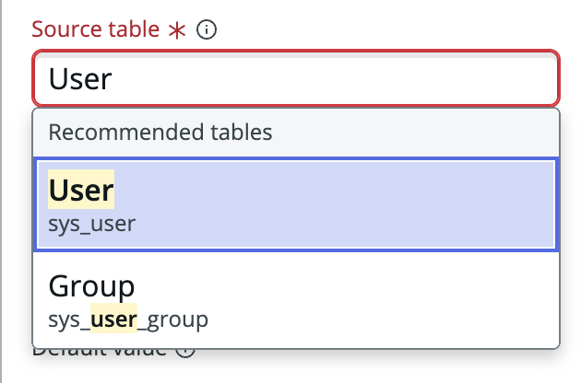Click to edit **Question 3**Question label: **Recipient**  
   Content type: **Record Choices**Source table: **User** [sys_user]  
   Click **Save and close**

**Note:** for this *(20)* question, we choose to reference a ServiceNow table.

This gives us the option to dynamically populate a popup with data available   
in the platform.

1. 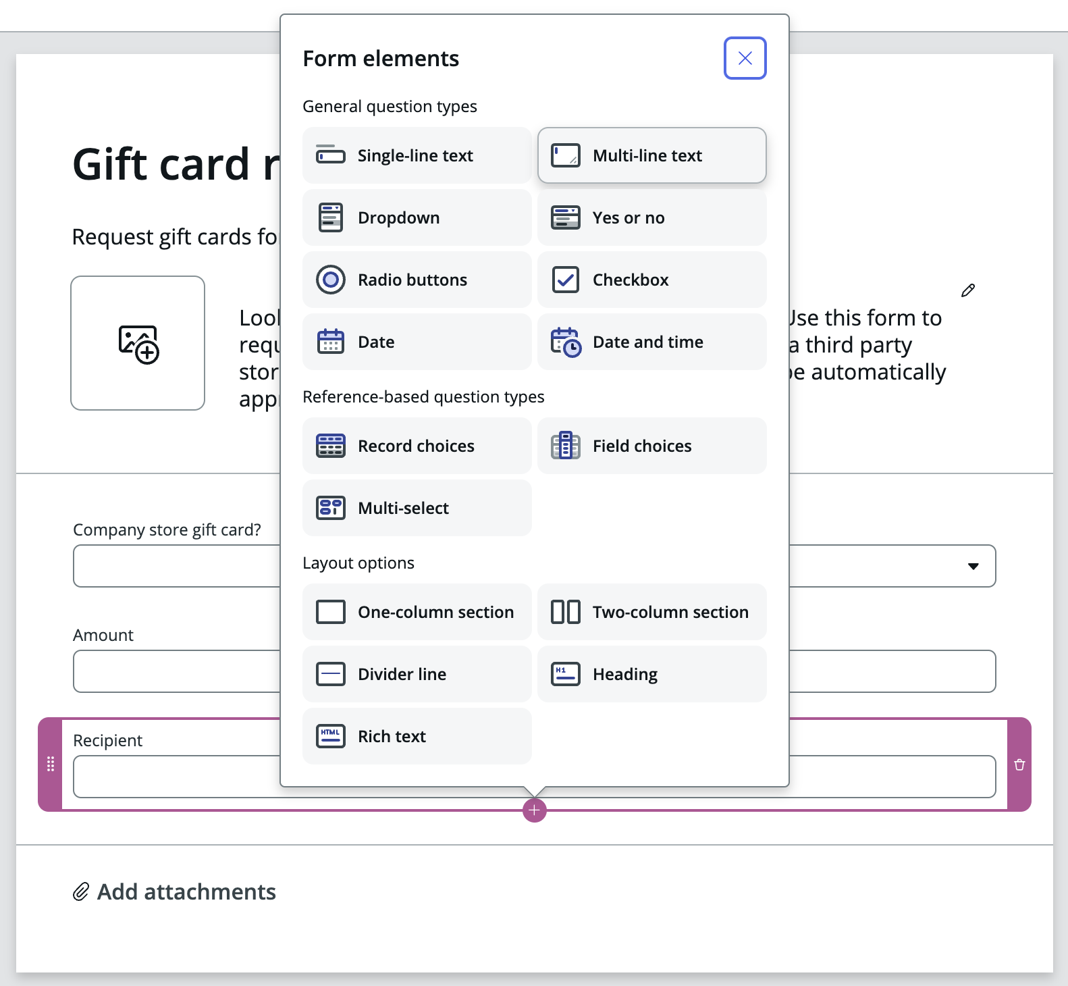Add another form element to capture the **Justification.**With the bottom form element *Recipient* selected – click the **Plus +**  that shows up below the form element and choose to add a   
   **Multi-line text** element.  
     
   Alternatively, drag and drop a a **Multi-line text** element from the Form elements section on the left on to the Edit area.  
     
   Give the element a label: **Justification.**Click **Save and close**

Section Complete

Congratulations, you have now created the form for your application.

Your next step will be to design the processes that takes care of the approval from the requesters manager and the appropriave approval group.

Create a Playbook for Automation

In this section we will create a playbook for automation and design the approval process.

We will create a playbook that runs when the user request a gift card from an external store (when user select NO for the “Company store gift card?” question you created earlier.

1. Click **Automations** on the top tab section.
2. Clic **Create** **a new playbook** and name it **Auto approve internal gift cards**
3. In the Create playbook popup, scroll down to **Filter conditions** and click **+ Add conditions**.  
   In the **Select field** popup for the filter conditions, click and scroll to the bottom to **Questions.**You can then either type, next to the magnifying glass, what you’re looking for (Hint: gift card) or scroll down to it on the right hand side.  
   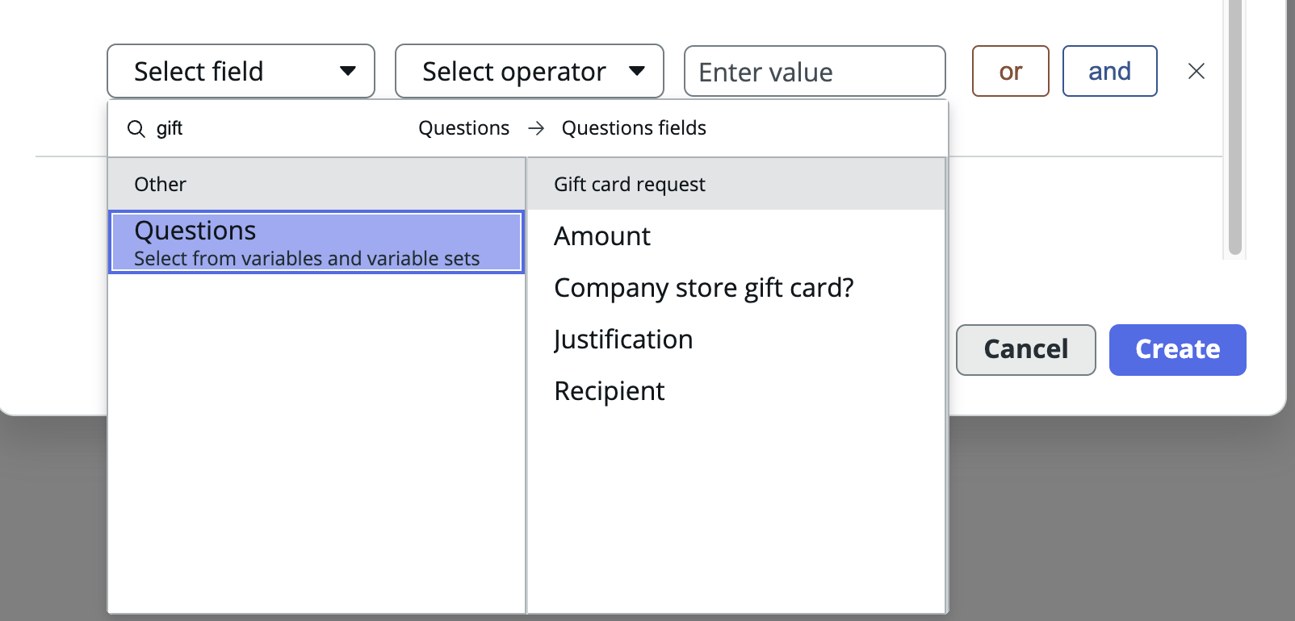  
   Select **Company store gift card**
4. Next select **is** as a selector in the middle popup and **No** in the last *(Enter value)*.  
   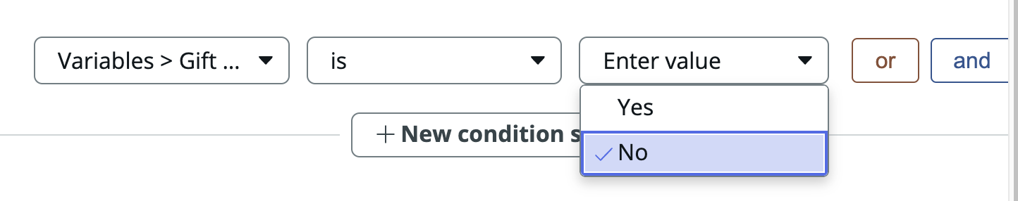  
     
   Note: Due to a UI-glitch in the Lab instances, you will not see that you selected “No” in the last poup – it will show “Enter value” reglardless of what you choose. Don’t worry, your selection is still made.  
   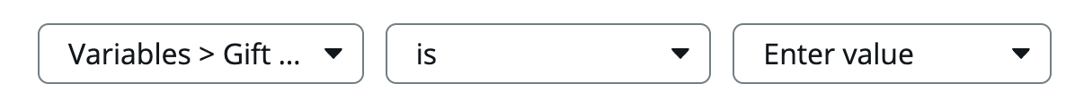
5. Click **Done**!

We have now created a Playbook that triggers when it’s needed. Our next step is to define the actions we want. The **Fulfillment steps**.

We will now create steps to request approval from the requesters manager

The orange box **Fulfillment steps** will contain your logics.

Since Creator Studio is all about simplicity, the user is limited to one fulfillment step. More advanced playbooks can be built using **Workflow Studio** but, that’s for another lab.

**Note:** When you open a popup in this view to add or configure steps, your work is saved as soon as you click **Save and close** in the popups shown.

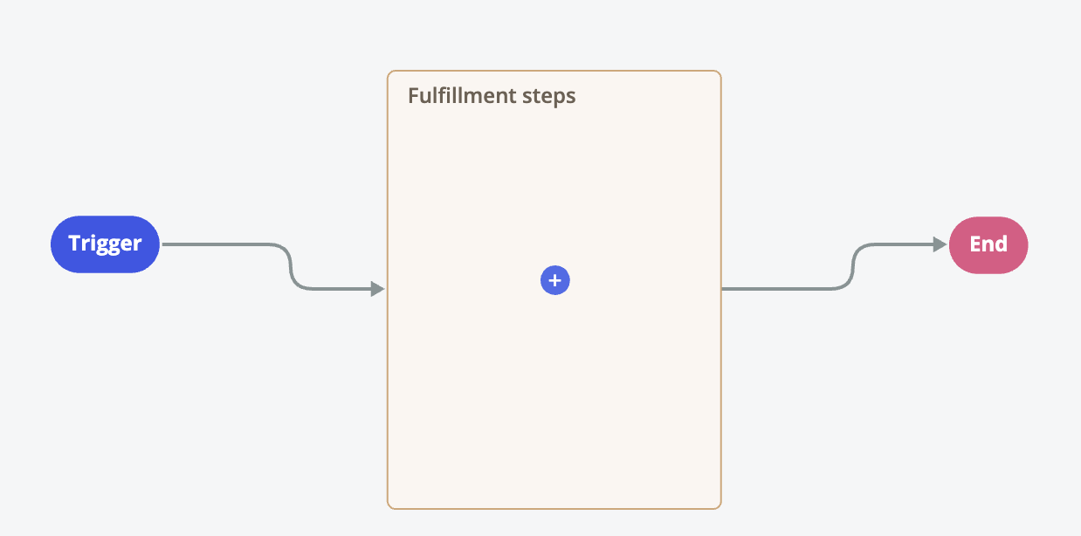

1. Click the **Blue +** to add a new step.  
   You then get two options.  
   The top **Romb** symbol creates a **Decision activity** (if/then)  
   The bottom **Square** symbol adds an activity.  
   Click the bottom **Square** to add an activity.
2. In the popup shown, choose to add a **Request approval** activity.  
   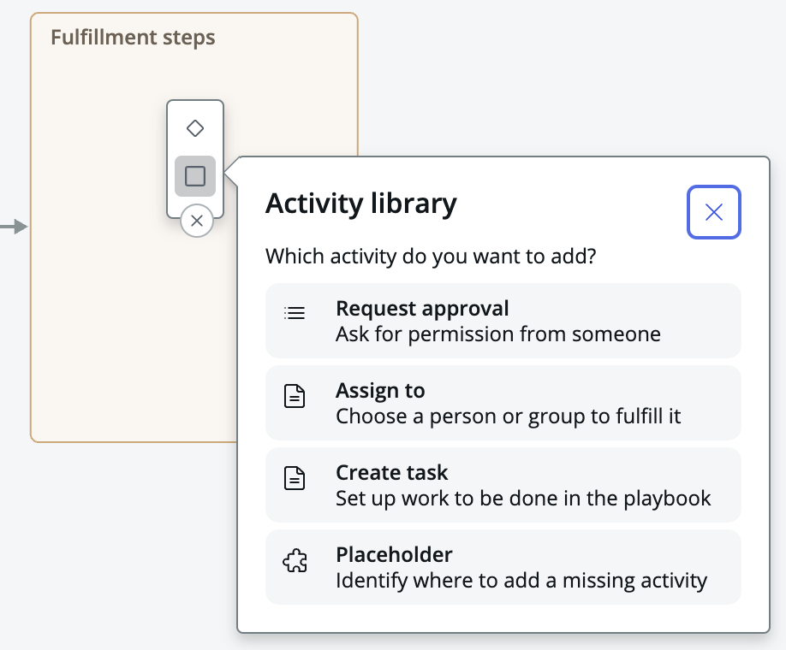
3. In the properties for the **Request approval** activity, update the Name to **Request manager approval** and select the checkbox for **Requestor’s manager**.  
   Click **Save and close.**
4. In the top right of your screen, click **Activate** to make the new Playbook active for all new requests.  
   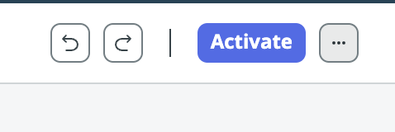

Section Complete

Congratulations, you have now created playbook automation for your request.

Next, let’s review the workspace used to fulfill the requests.